AI BLOGNEST
Project Planning Phase
Date | 25/09/2026
Team ID | SWTID-2026-6744
Project Name | AI BlogNest

Team Leader : KARTHICK M/ Team Members : KANNAN G, SATHISH K ,
HARIHARAN S

PHASE 5: PROJECT DEVELOPMENT PHASE

5.1 server.js
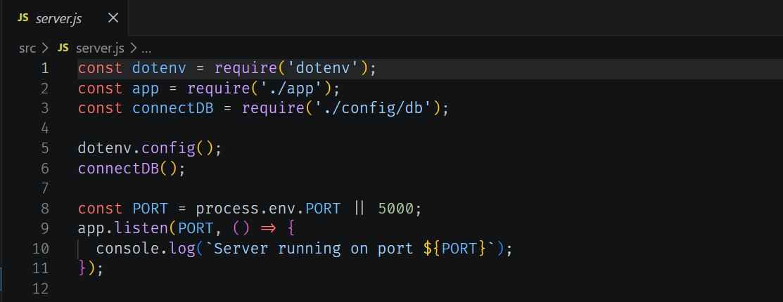
Fig 5.1 — server.js 5.2 app.js
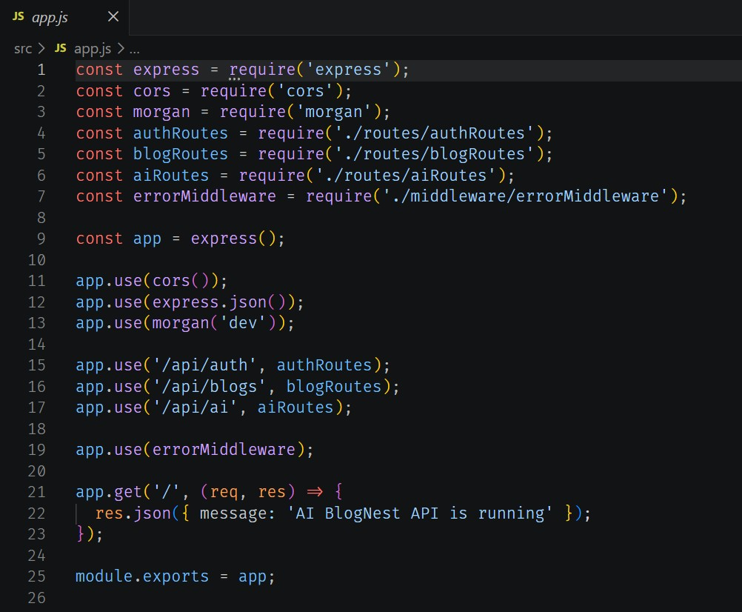
Fig 5.2 — app.js

5.3 Database Connection
Ensure the database is connected before performing any backend operation. The connection setup is shown below.
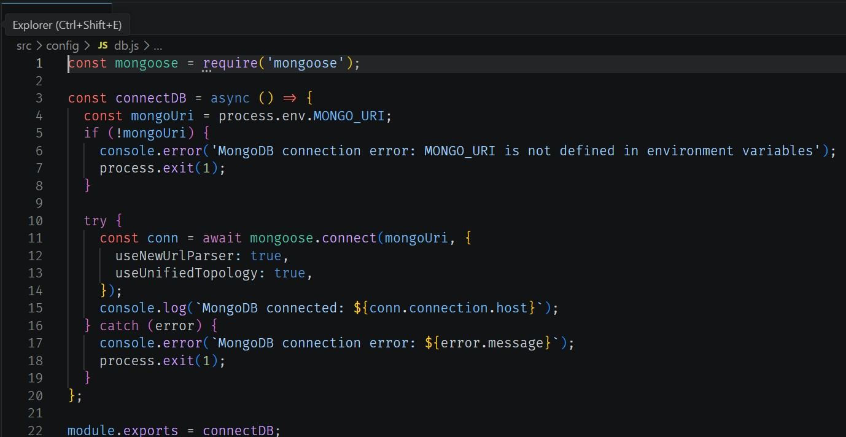
Fig 5.3 — Database connection code
- Install Mongoose: npm install mongoose
- Create the database connection.
- Create schemas and models.
5.4 Mongoose Schema Definitions

Identity Resource Document Schema (schemas/userModel.js)
Enforces field-level validation on incoming database records:
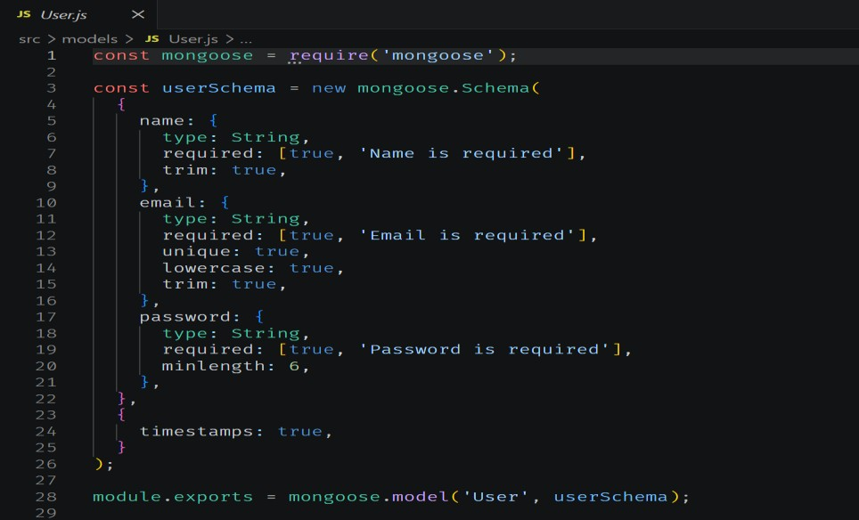
Fig 5.4 — userModel.js schema

5.5 AI Flow Integration
The AI Flow service layer connects to Google Gemini AI via dedicated endpoints, allowing controllers to offload complex text-processing tasks:
- /api/ai/generate-blog — the BlogGenerator service synthesizes full-length, structured blog posts from high-level thematic prompts using context-aware templates.
- /api/ai/summarize — the summarization engine parses extensive article payloads and generates concise abstracts and metadata summaries via semantic compression.

